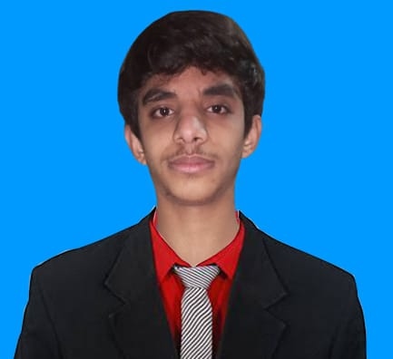

FARMAN ANEES

Address: Street no 17 House no 3 main Bazar Quasar Pura Ravi Road, Lahore

Contact No: 03164569841

Email: [farmananees234@gmail.com](mailto:farmananees234@gmail.com)

**OBJECTIVE**

“To join an organization where I can utilize my skills and experiences to make valuable contribution towards the achievement and over all goals of the organization through continuous efforts, the focus of attention would on the growth and development of the organization”

**EDUCATION**

|  |  |  |  |  |
| --- | --- | --- | --- | --- |
| **DEGREE** |  | **INSTITUE** |  | **YEAR** |
| * MATRIC | : | MUHMMADAN ACADEMY LAHORE | : | 2019 |
| * Intermediate | : | GOVT. DIYAL SINGH COLLAGE LAHORE | : | 2021 |

**WORK EXPERIENCE**

* Fresher

**PERSONAL INFORMATION**

|  |  |  |
| --- | --- | --- |
| * Father Name | : | Muhammad Anees Aslam |
| * Date of Birth | : | 17/April/2002 |
| * CNIC No | : | 35202-9325 |
| * Gender | : | Male |
| * Nationality | : | Pakistani |
| * Religion | : | Islam |

**REFERENCE**

Will be furnished on demand